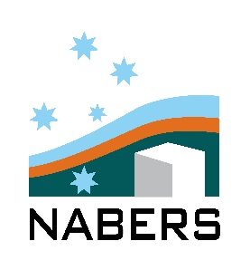

NABERS Creative Stars

Entry form

Your name & position
<insert name here>

Your contact details
<insert contact details here>

Your company
<Insert company name>

Your building
<Insert building address>

Your NABERS rating(s)
<insert rating(s) – type, star rating, expiry date>

Please provide an explanation of your display
<insert explanation>

Has the display met the following mandatory criteria?
- It is clearly identifiable as NABERS
- It shows the full star rating in context (i.e it cannot be 4 stars out of 4)
- It shows the expiry date
- It contain some reference the specific premises, the rating type and the rating scope
- Any use of the logo must adhere to the ‘NABERS Ratings symbol brand guidelines’.
<Yes / No >

What is unique about your display?
<insert explanation>

How does your display engage visitors to the building?
<insert explanation>

How does your display educate viewers about your building’s sustainability journey?
<insert explanation>

How have you made your display sustainable?
<insert rating(s) – type, star rating, expiry date>

Please submit this form with high resolution images of the project to info@nabers.gov.au. Please direct queries to francis.roberson@environment.nsw.gov.au or (02) 9995 5457.

